**DAILY ONLINE ACTIVITIES SUMMARY**

|  |  |  |  |  |  |  |  |  |
| --- | --- | --- | --- | --- | --- | --- | --- | --- |
| **Date:** | **13/06/2020** | | | | | **Name:** | **RITIKA KULKARNI** | |
| **Sem& Sec** | **4thSEM. & ‘B’ SEC.** | | | | | **USN:** | **4AL19CS403** | |
| **Online Test Summary** | | | | | | | | |
| **Subject** | | **Data Communication** | | | | | | |
| **Max. Marks** | | **30** | | **Score** | | | **19** | |
| **Certification Course Summary** | | | | | | | | |
| **Course** | **Introduction of Information Security** | | | | | | | |
| **Certificate Provider** | | | **Greatlearning**  **Academy** | | **Duration** | | | **5 Hrs.** |
| **Coding Challenges** | | | | | | | | |
| **Problem Statement:**   1. **Given an integer U denoting the amount of KWh units of electricity consumed, the task is to calculate the electricity bill with the help of the below charges:**   **• 1 to 100 units – Rs 10/- Per Unit**  **• 100 to 200 units – Rs. 15/- Per Unit**  **• 200 to 300 units – Rs. 20/- Per Unit**  **• above 300 units – Rs. 25/- Per Unit** | | | | | | | | |
| **Status: Executed** | | | | | | | | |
| **Uploaded the report in Github** | | | | | **Yes** | | | |
| **If yes Repository name** | | | | | <https://github.com/ritikakulkarni> | | | |
| **Uploaded the report in slack** | | | | | **Yes** | | | |

**Online Test Summary: AADALITHA KANNADA test was scheduled from 11:00 am to 11:25 am. The portion for the IA was all module there were 25 questions and the time assigned was 25 minutes the questions were mcq type. But there was an issue with the time mentioned, so that we got only 30mins. to finish the test. The time was not sufficient to answer all the questions.**

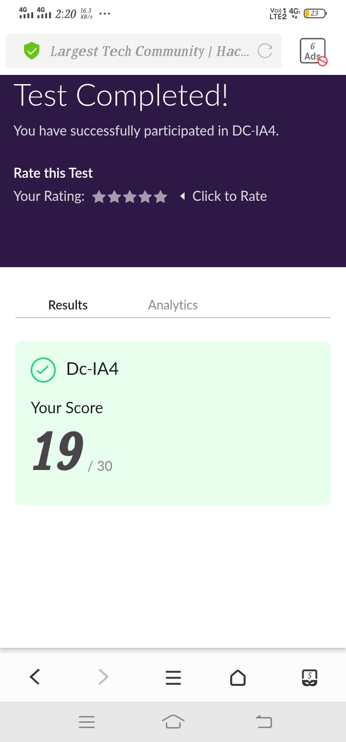

**Certification Course Summary: Today, I went through the what is cybersecurity Risk Trends in Cyber Security which helps to execute the code and to achieve the output and some of the basic security commands.**

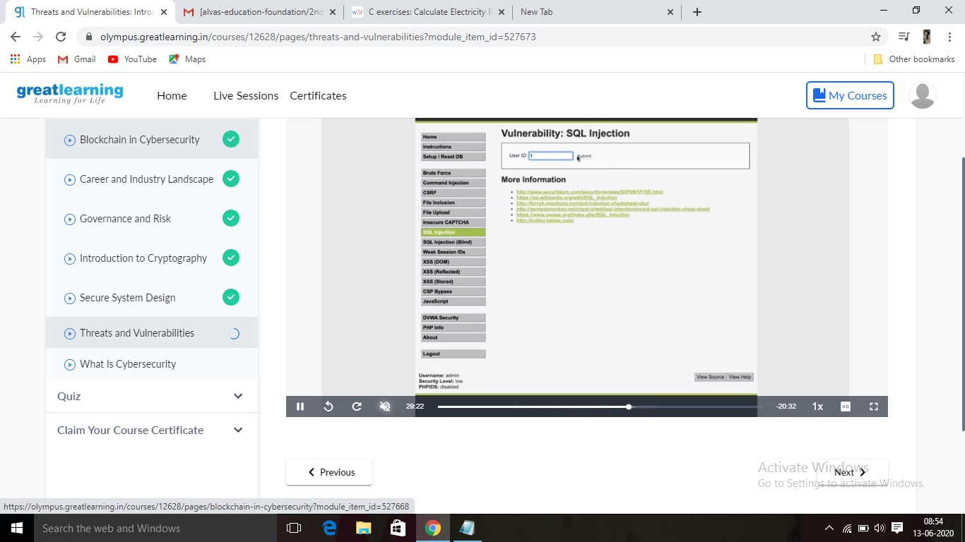

**Online Coding Summary:Online Coding Summary​: Online coding Summary: Today I received two program from Prof. Vasudev CSE Dept. The program is mentioned above(pg.01). to my GitHub repository and I’ve shared the snapshot below.**

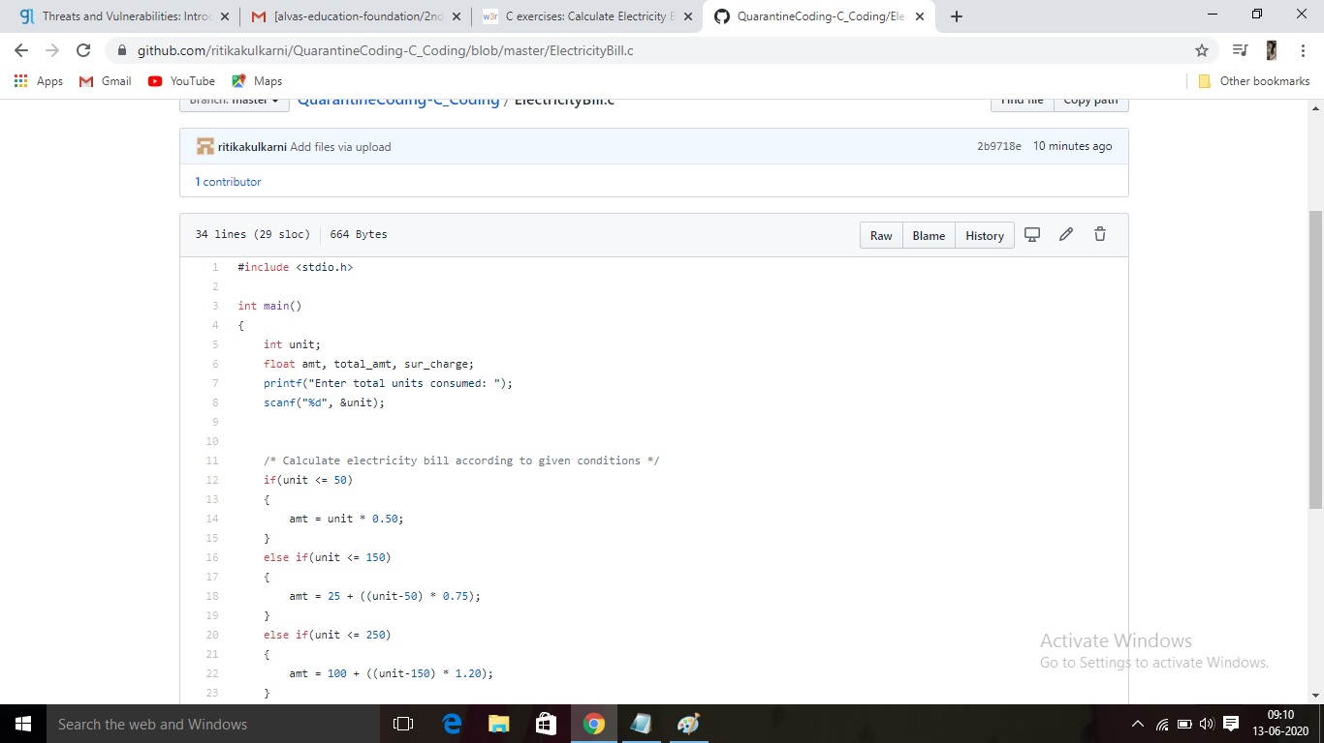 **Thank you.**